Battle formations in Real-Time Strategy Games

# Scope:

* Have a group of units change into different types of formations formed around a leader
* On a 2d plane
* Dynamic formations based on the terrain type
* What if a unit dies?

What is a formation? -> It is defined as an arrangement or disposition of units.

How do we define a dynamic formation? 🡪 A group of cooperating units that are capable of adapting to changing circumstances. To have this formation we require 5 aspects:

1. A dynamic formation shape (a non-fixed shaped)
2. Units in the formation are positioned properly
3. Units in the formation are capable of moving as a group
4. Units in the formation select ‘intelligently’ which enemy to attack
5. Units in the formation cooperate in their combat behavior

My research will be focusing mainly on the formation and group movement aspect without having to attack an enemy, so point 4/5 will not be looked at for now.

# SHAPE OF THE FORMATION

line

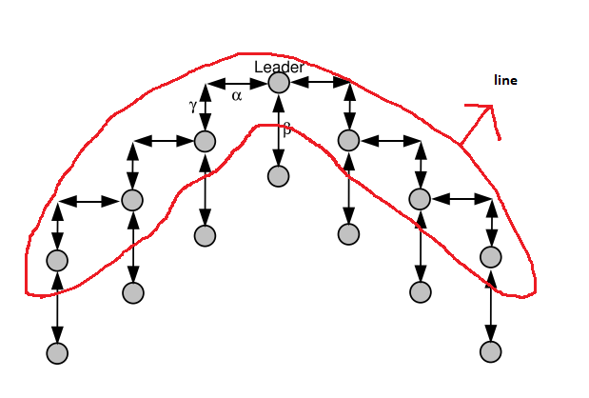

In the above figure a general design of a dynamic formation is illustrated, the architecture of this shape allows for numerous dynamically determined shapes of the formation.

There are multiple parameters that define the shape of the formation:

Since we won’t be using the formations to ‘attack’ an opponent, we can ignore the last 2 parameters

Firstly, all the units will be divided over ϕ (=number of formations) formations, each of these formations can then have a separate shape.

A formation is constructed from a grid, arranged in *lines* of positions with each line consisting of a fixed number of units ψ (=number of units per line).

The units on the first line have a distance α(=distance between units on the first line) between each other. Any following line will have a distance β(=horizontal distance between different lines of the same group) behind its predecessor.

The formation is centered around a so called ‘leader’ unit which determines the general direction of the movement and the speed of the formation. This unit is positioned in the middle of the first line.  
The units on the left and on the right of the leader are positioned a distance of γ(=vertical distance between the units of neighboring rows) either in front or behind the leader, depending on the value of γ.

# POSITION OF THE UNITS

First, the position of the units is determined according to their X-Coordinate on the map, units move to the closest formation to speed up the process.

Second, units are distributed over the defined lines according to their Y-Coordinate.

Third, the position of an individual unit on a line is assigned according to the X-Coordinate of this unit.

To determine the position of a unit via an algorithm, we use O(n log n) where ‘n’ is the number of units.

# MOVEMENT OF THE FORMATION

For our movement we firstly, calculate the direction of where the leader should move towards.

Second, we set the other units in the formation to follow in the direction parallel to the direction of the leader.

Sources:

<https://sander.landofsand.com/publications/CIG08Heijden.pdf>